|  |  |
| --- | --- |
| http://www.viit.ac.in/images/viitlogo.gif | **BRACT’s**  **Vishwakarma Institute of Information Technology**  **(An Autonomous Institute Affiliated to SPPU Pune)** |

**Vishwakarma Research Project Scheme (VRPS)**

**2020-2021**

**PART – A (Technical Proposal)**

**1. Title of the research proposal**

Supply Chain Traceability Using Blockchain for organic food products like Jaggery.

**2. Introduction of the research proposal**

A supply chain is a network between a company and its suppliers to produce and distribute a specific product to the final buyer. This network includes different activities, people, entities, information, and resources. The supply chain also represents the steps it takes to get the product or service from its original state to the customer.

A supply chain involves a series of steps involved to get a product or service to the customer. The steps include moving and transforming raw materials into finished products, transporting those products, and distributing them to the end-user.

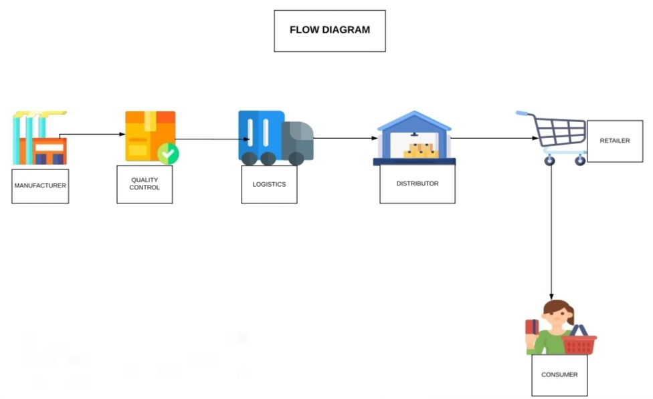

This project is intended to explore transparency in the supply chain of organic products like Jaggery by the usage of Blockchain technology. It allows for decentralized data storage and provides immutability. The decentralized data storage makes it impossible for an unauthorized actor to tamper the data.

Various actors involved in the supply chain are Producers, Distributors, Retailers, Customers, and Quality Checkers. The customers can query the product information by entering the unique code and know the status and events on the product in the supply chain. Various tools are being studied such as Ethereum, Enterprise Ethereum, Multichain, Hyperledger Fabric, Hyperledger Sawtooth to find the efficient one for this supply chain use case.

This project is expected to replace the ongoing methods employed by the industry to trace products in the supply chain, thus leading to an immense decrease in cost and efforts for the producers and making the products cheaper for the customers. The blockchain could also be deployed on cloud services to increase availability and reliability.

This project can be used by any organic product manufacturing industry that wants to better track the products and explore transparency in the supply chain.

**3. Origin of the research problem**

Nowadays, the customers are unaware of the events happening to the items in the supply chain which creates a lack of trust in their minds. So, the solution to this problem can be implemented efficiently using blockchain technology. Organic Food should reach in the hands of customers when they are fresh and quality is preserved. The use of IoT sensors can measure the temperature and humidity of the surroundings in which the organic food is stored which can indicate if the quality is compromised.

**4. Interdisciplinary relevance**

The application is coupled with manufacturing industries producing organic food items. The project also uses IoT sensors to feed temperature and humidity data into the blockchain to verify the quality of the product.

**5. Project Impact - Expected outcome**

The solution deployed will be able to trace organic food items in the Supply Chain from manufacturers to the end-user of the product.

The solution will also reduce the cost and effort spent by the industry to trace the products and recalling those products in case of any mishappenings e.g. improper storage conditions deteriorating the product quality below the par.

**6. Review of research and development in the subject**

**(a) International status**

1. A similar application FoodTrust has been developed by IBM to bring transparency in the Supply Chain for Walmart Food stores, using the Hyperledger Fabric framework, which reduced time taken to trace products from days to few seconds.
2. Provenance pilot blockchain technology for tracing yellowfin and skipjack tuna fish in Indonesia from catch to consumer. Mobile, blockchain technology and smart tagging were used to track fish caught by fishermen with verified social sustainability claims.
3. Starbucks is working with Microsoft to develop a blockchain-based supply chain tracking system and mobile app that will allow customers to track the supply chain journey of the beans they buy and the coffee they drink.
4. Amazon is also planning to develop a Blockchain-based application that will trace products in the Supply Chain.

**(b) National status**

1. An application to trace organic fruits and vegetables has been deployed by Sahyadri Farms, Nashik using the MultiChain platform.
2. Kryptech is a full-stack blockchain development company based out of Mumbai, India. The company offers Supply chain finance(SCF), a decentralized supply chain marketplace that connects suppliers, buyers, and banks/NBFCs for supply chain financing based on invoice discounting.

**7. Significance of the study in the context of current status**

When any organic product is purchased by the customer and it turns out to be non-compliant with the quality, the retailer is hesitant to accept the product. Even if the retailer accepts the product from the customer, any other entity such as Manufacturer, Distributor or wholesaler has to incur the losses, even if the quality is not compromised by that actor. If this system is in place, the point where the quality was compromised can be tracked and the related actor has to incur the losses.

The customer expects great service. They’re giving you money to perfectly satisfy their needs to get a product on time and in one piece. If a problem does arise, they want your company to have the transparency to show why it occurred, and what you’re going to do for them to fix it. The Customer experiences efficiency in tracking the product and transparency helps to satisfy him/her.

**8. Objectives**

1. To develop confidence in the minds of the customers about the quality while purchasing the product, thus increasing trust of customer on the product and industry
2. To trace products in a reliable and tamper-proof environment with no central authority controlling the data.
3. To reduce costs and labor employed by the industry to trace products to the customer in case of any mishappenings during the production or delivery of the product.

**9. Methodology**

1. The backend i.e. business logic  will be developed using JavaScript language on the MultiChain framework which is based on Blockchain technology.
2. The frontend i.e. user interface will be developed using HTML, CSS, JavaScript, and use of any particular frontend framework like AngularJS, ReactJS.
3. The nodes representing the various actors will be deployed on AWS Cloud Services to ensure high availability and fault-tolerant working of the application.

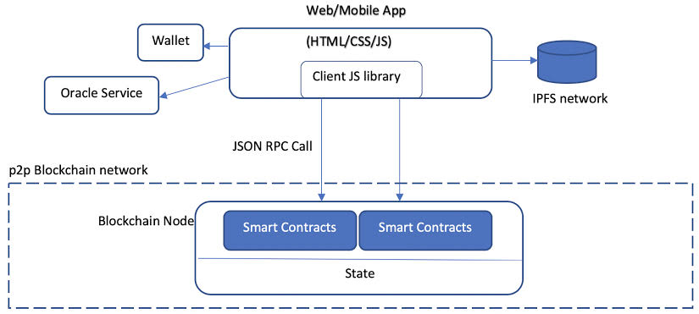

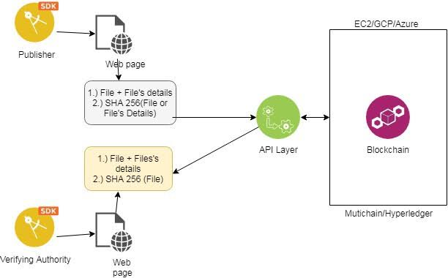

**10. Year wise plan of work and targets to be achieved (expected time schedules for the various activities of a proposed investigation)**

|  |  |  |  |  |  |
| --- | --- | --- | --- | --- | --- |
| **Sr.** | **Expected target to** |  | **First Year** | |  |
| **No.** | **be achieved** | **4 months** | **4 months** |  | **4 months** |
| 1. |  |  |  |  |  |
| 1.  2.  3.  4. | Basic traceability of the products  Implementing special cases and deploying solution  the cloud.  Integrating IoT sensors in the application to track products in real-time  Report submission and paper publication. |  |  |  |  |
|  |  |  |  |
|  |  |  |  |
|  |  |  |  |
|  |  |  |  |  |  |

**11. Likely Impact (Please attempt to quantify)**

1. Reduction of cost used to trace the product back to its origin from tens of thousands of rupees to a fixed cost of merely a hundred rupees.
2. Reduction of time required to trace products from weeks to seconds.
3. A marginal reduction in products’ costs because of the benefits mentioned in the above steps.
4. Increased transparency of the entire supply chain process which is open to the majority of actors thus increasing trust among the actors and reduction in malpractices.

**12. Parameters for monitoring effectiveness of project**

1. Successful tracing of products in lesser costs and time.
2. Identifying the point in the Supply Chain where the quality was compromising and penalizing that actor.

**13. Suggested Post Project Activities**

1. Extending the supply chain to include farms before the manufacturing industry to assess the quality of raw materials using IoT sensors to have full transparency.
2. Involving FSSAI in the Supply Chain to verify compliance of quality standards for sugarcane and jaggery and to get quality compliance certificate.

**Part B (Financial Proposal)**

|  |  |  |  |
| --- | --- | --- | --- |
| **Sr No** | **Item/Specifications** | **Year 1 (Rs)** | **Year 2 (Rs)** |
| **1** | **Equipments**  **i)** **DHT22 AM2302 Temperature and Humidity Sensor**  **ii) Raspberry Pi** | **₹799/-**  **₹4000/-** |  |
| **2** | **Consumables**  **i) AWS Cloud Services** | **₹2000/-** |  |
| **3** | **Other Expenses**  **(Give details)**  **i) Paper publication** | **₹3000/-** |  |
|  | **Total** | **₹9799/-** |  |
|  | **Grand Total** | **₹9799/-** | |

**PART- C (Declaration)**

**To certify that:**

(a) I / We shall abide by the rules and regulations of Vishwakarma Research Project Scheme and accept to be governed by all the terms and conditions laid down for this purpose in case assistance is provided to me/us for the said project.

(b) I / We shall complete the project within the stipulated period. If I / We fail to do so and if the Institute is not satisfied with the progress of the said research project, the Institute may terminate the project immediately and ask for the refund of the amount received by me / us.

(c) The above research project is not funded by any central government/state government/public sector agency during the period to which the grant relates.

**Name & Signature of the Principal Investigator:**

Mr. Ayush Bansal

**Department: Information Technology Designation:  Student**

**Date of Joining VIIT: 31/07/2017**

**Name & Signature of the Co-Investigator:**

Mr. Aadesh Ingle

Mr. Ashish Gole

Mr. Lokesh Budhlani

Mr. Siddesh Vyavahare

**Department: Information Technology Designation:  Student.**

**Date of Joining VIIT: 31/07/2017**

**Name & Signature of the Advisor:**

Dr. Priya M. Shelke

**Department: Information Technology Designation: Associate HOD**

**Date of Joining VIIT: 13/06/2005**

**Head of the Department**

**(Signature)**